**DAILY ONLINE ACTIVITIES SUMMARY**

|  |  |  |  |  |  |  |  |  |
| --- | --- | --- | --- | --- | --- | --- | --- | --- |
| Date: | 1/06/2020 | | | | | Name: | Jyothi B R | |
| Sem & Sec | IV-A | | | | | USN: | 4AL18CS030 | |
| Online Test Summary | | | | | | | | |
| Subject | | Complex Analysis Probability and Statistical Method | | | | | | |
| Max. Marks | | 29 | | Score | | | 30 | |
| Certification Course Summary | | | | | | | | |
| Course | Programming Essentials in Python | | | | | | | |
| Certificate Provider | | | Cisco Virtual Academy | | Duration | | | 2.5hrs |
| Coding Challenges | | | | | | | | |
| Problem Statement.1. Define a class Point with two fields x and y each of type double.  2.sub array | | | | | | | | |
| Status:Completed | | | | | | | | |
| Uploaded the report in Github | | | | | Yes | | | |
| If yes Repository name | | | | | https://github.com/alvas-education-foundation/jyothi_b_r | | | |
| Uploaded the report in slack | | | | | Yes | | | |

Online Test Details: (Attach the snapshot and briefly write the report for the same)

Certification Course Details: (Attach the snapshot and briefly write the report for the same)

Coding Challenges Details: (Attach the snapshot and briefly write the report for the same)

ONLINE TEST DETAILS:

The online test was from module 5. There were 20 questions which contains 10 mcq for 1 mark and 10mcq for 2 mark questions and the duration were 40 minutes. The questions were optimal and easy. The score that I received was 29/30.

**Snappshot :- not taken**

CERTIFICATION COURSE DETAILS:

Programming Essentials in Python :

**Parametrized functions**

The function's full power reveals itself when it can be equipped with an interface that is able to accept data provided by the invoker. Such data can modify the function's behavior, making it more flexible and adaptable to changing conditions.

In this class it says about how to define the function and parameters. Which is used to initialise the value inside and outside the parantheses.

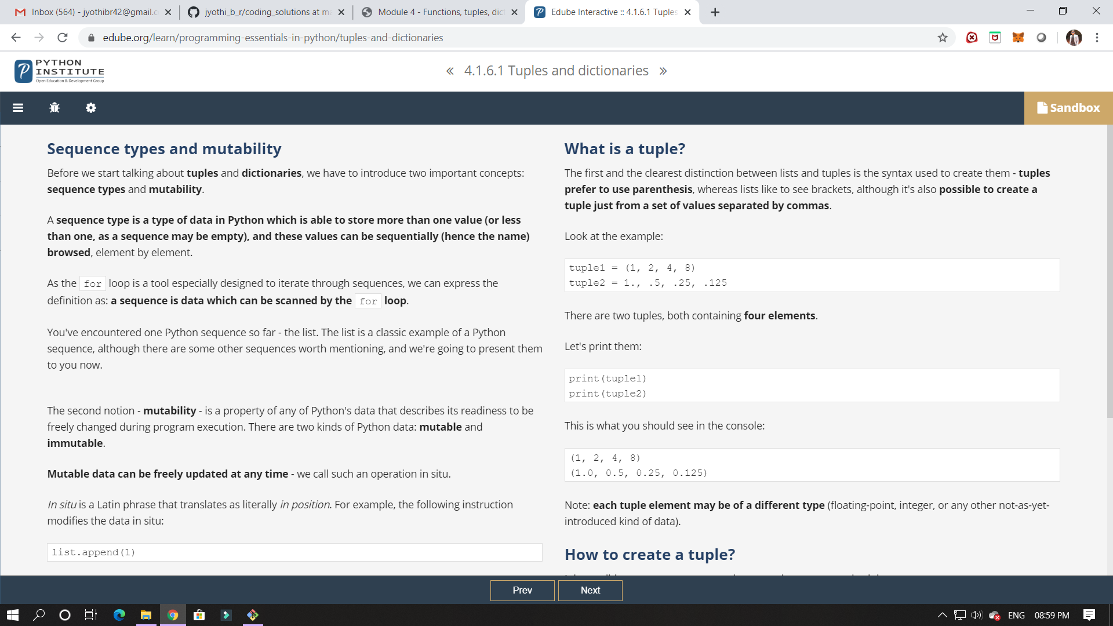

In this class I have learned about tupple and its classification.

ONLINE CODING:

1.Define a class Point with two fields x and y each of type double. Also , define a method distance(Point p1, Point p2) to calculate the distance between points p1 and p2 and return the value in double.. Use Math.sqrt( ) to calculate the square root.

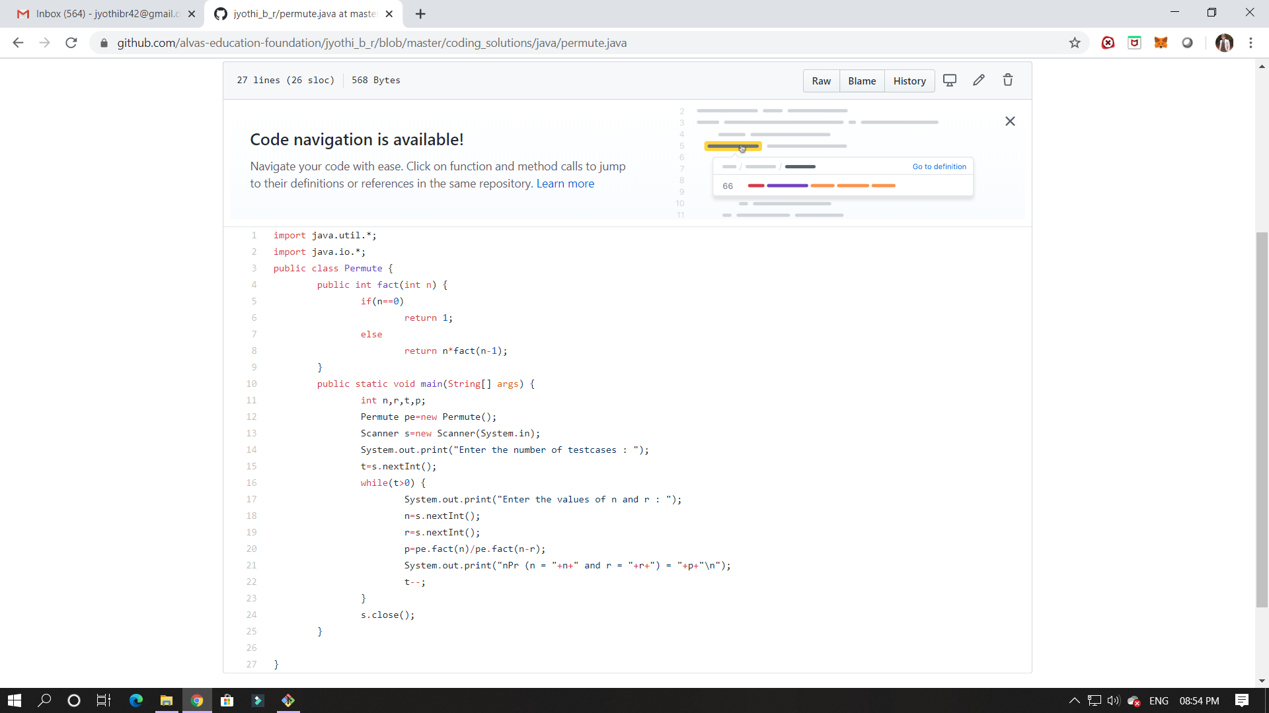

2.  Given an array arr[] of size N and an integer K. The task is to find the count of subarrays such that each subarray has exactly K distinct elements.

